**G1S1 -Graded Project 3-Python for DS**

**Screenshots of Flask App**

1. **Home page**

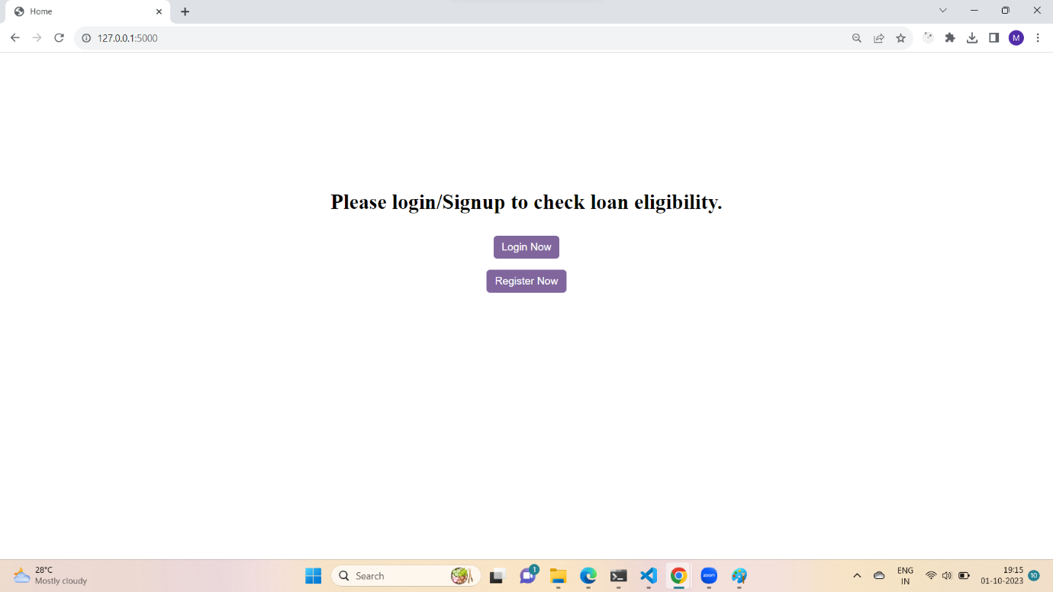

1. **Register Page**

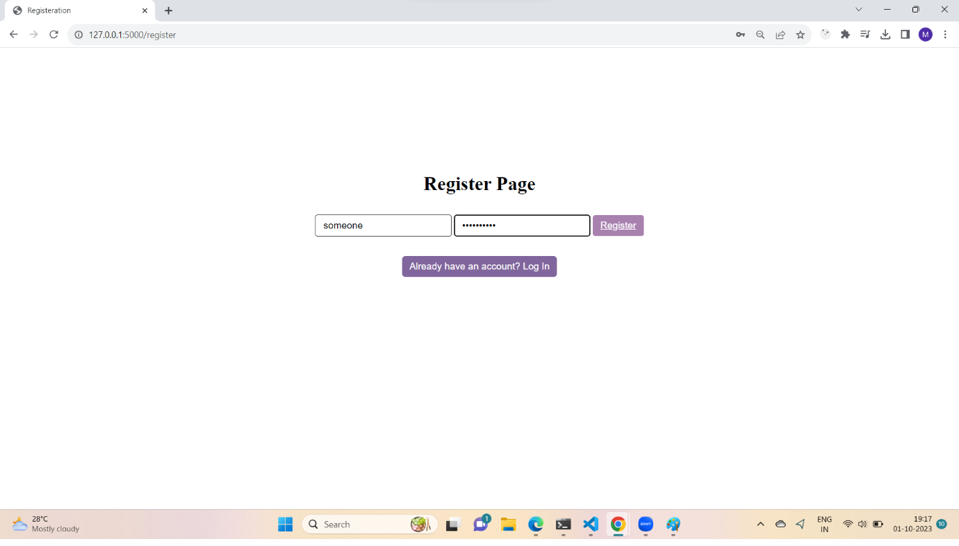

1. **Data stored in MYSQL Database**

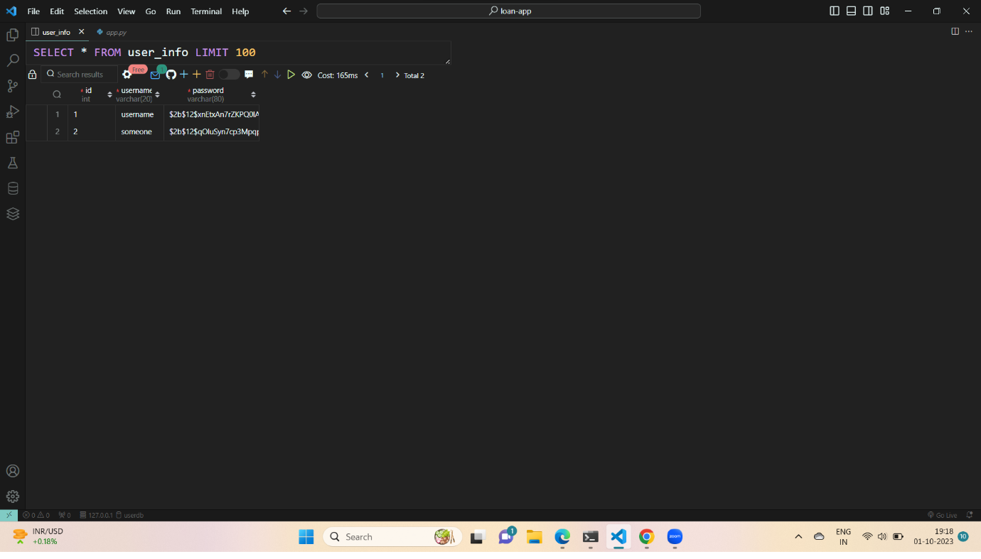

1. **Login Page**

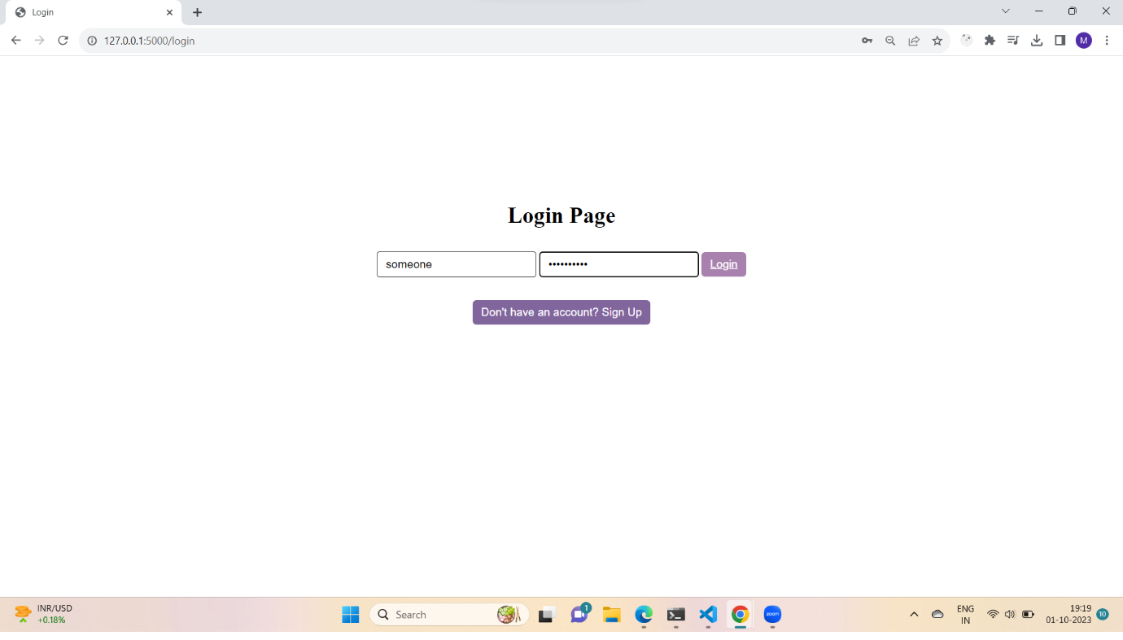

1. **Predict page- Prediction Case 1 values**

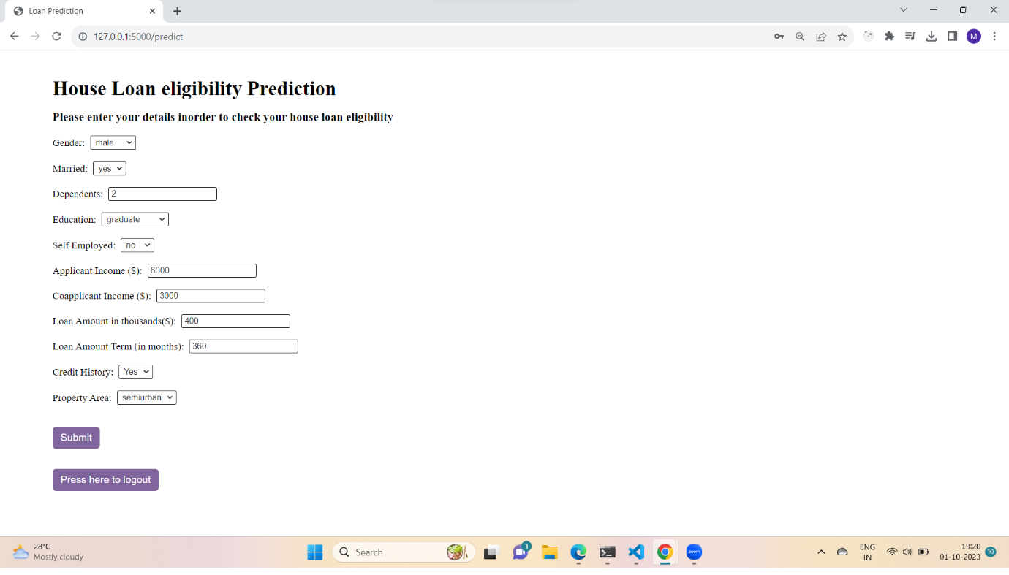

1. **Prediction Case 1 -results**

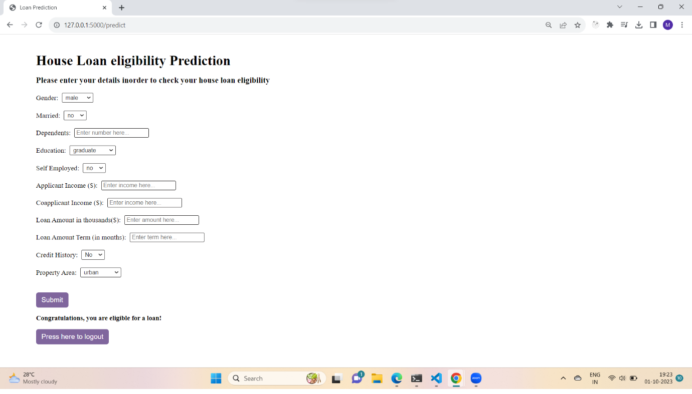

1. **Prediction Case 2- Values**

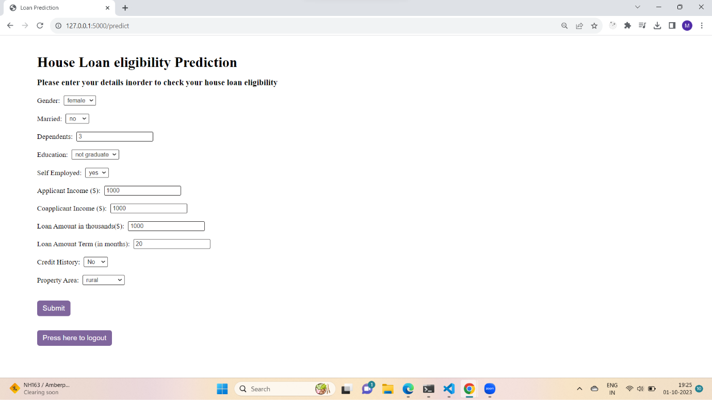

1. **Prediction Case-2 Results**

